INTERNAL PRODUCT SPECIFICATION (IPS)

MODEL NUMBER ： 8668

PRODUCT NAME ： Shure Blackhawk 1S1P battery pack

CUSTOMER ： Shure

REFERENCE ： BOM-8668

ICC P/ N ： 03-58668-001

P/N Printed on Label | Shure model NO: | Inventus PN
 |  | 03-58668-001

THIS SPECIFICATION COVERS THE PERFORMANCE CHARACTERISTICS AND PRODUCTION TEST REQUIREMENT FOr U Battery pack

Revision History
Revision | Originator | Reason for change | Date
X1 | Ben feng | New release | Mar/12/2020
X2 | Alan Cheng | Update item 2 of Product information Version List | Apr/9/2020
X3 | Kandy | Update item 4, 5 of Product information Version List | May/15/2020
X4 | Kandy/Elon/Angus | Update item 4,6 of product information version list | June/16/2020
X5 | Tounme | Update item 3 and item 6 | June/18/2020
X6 | Kandy/Dajie | Update item 5 of product information version list | June/19/2020
X7 | Kandy/Ray | Update item 6 of product information version list | July/1/2020
X8 | Alan | Update item 2 of product information version list | Oct/12/2020
X9 | Ben | Update Item 4.8 and 5.4.4 OCC change from 2.9A to 1.8A | Oct/13/2020
X10 | Jinxiang/Dajie | Update item 5 of product information version list | Oct/16/2020
X11 | Tounme | Update item 6: delete requirement for 3 cycles of battery charge/discharge in Acceptance Criteria, including drop test, Vibration Random (Min Integrity Test) and insertion testing | Nov/11/2020
X12 | Tounme | Update items 3 and 6 | Mar-24-2021
X13 | Ben | Update Item 5.5.2 ,5.5.4 | Mar/25/2021
X14 | Jesse | Update item 6 of product information version list | Mar/30/2021
X15 | XZH/Richard | Add label and package information for item 8.1~8.4 | Mar/30/2021
X16 | Tounme | Update items 3 | Apr-02-2021
X17 | Elon/Yanke | Update item 3 of product information version list | Apr/08/2021
A | Nico / Kyle | Update to A version | Apr/08/2021
B | Jinxiang/Kim/Elon | Update item 4 and 5 of product information version list | May/25/2022
C | Jinxiang/Fsun | Update item 6 of product information version list | Jul/4/2023

Table of contents

INTERNAL PRODUCT SPECIFICATION (IPS) 1
Revision History 2
Table of contents 3
Product information Version List 3
1. SCOPE 4
2. GENERAL REQUIREMENT 4
3. MATERIAL AND CONSTRUCTION REQUIREMENTS 4
4. ELECTRICAL SPECIFICATION 5
5. PRODUCT TEST PROCEDURE 6
6. Mechanical 13
7. Quality Assurance Requirement 13
8. Package And Packing Test 13
9. Engineering Change 14

Product information Version List
Item | Designation | Document Name | Version | Issue Date
1 | Product Specification | NA
2 | Production code | 8668-Shure-Battery-RevA2(A50B9AFB)-10122020.srec | RevA2 | Oct.12.2020
3 | Programming tool | Bq Studio + EV2300 + Fixture | N/A | Apr/08/2021
4 | Calibrator | 8668-Shure-Calibrator-Setup-Rev4.00(288E70C4)-05202022.zip | Rev4.00 | May/25/2022
5 | PCM tester software | PCM：  8668-Shure-PCM-Tester-Setup-Rev4.00(34DC1636)-05192022.zip | PCM：  Rev4.00 | May/25/2022
6 | Unit tester software | Unit/Info Verify/OQC:  8668-Shure-Unit-InfoVerify-OQC-Tester-Settings-File-Rev4.03(6A3AD8FF)-(2.8.4)-07032023.zip | Unit/Info Verify/OQC :  Rev4.03 | Jul/4/2023
7 | Cycle test software | Provided by QX | N/A | Oct/16/2020
8 | PCB | 95569-501-A1 | A1 | Jan.15.2020
9 | Schematic | 8556 Shure Lawrence 1S1P Battery schematic.pdf | A1 | Mar.12.2020
10 | PCBA level | NA
11 | Final Unit | NA
12 | Assembling Drawing | NA
13 | PCBA Label | NA
14 | Unit Label | 90947-723 LABEL UNIT 8668 | A | Mar/29/2021
15 | Inner box label | 90948-570 LABEL SN INNER BOX 8668 | A | Mar/29/2021
16 | Outer box label 1 | 90947-726 LABEL MASTER CARTON 8668 | A | Mar/29/2021
17 | Outer box label 2 | NA

1. SCOPE
This specification defines the performance characteristics and production test requirement for Shure Lawrence HH 1S1P Battery

2. GENERAL REQUIREMENT
Shure model is a rechargeable battery pack designed for use in the Blackhawk wireless microphone system. The pack includes a single Lithium-ion cell and features the TI Sn27742 fuel gauge with Impedance Track technology. The geometry of the battery pack facilitates use in the Blackhawk handheld microphone and subsequent products.

3. MATERIAL AND CONSTRUCTION REQUIREMENTS
Material and construction shall be exactly as specified by engineering document，BOM and mechanical drawing. No deviation is not permitted without written authorization from engineering. Materials are chosen such that the performance and product specification specified herein will be met when the battery pack is subject to the specified environment conditions.

3.1 Material requirement
Top and Bottom housing: PC/ABS CYCOLOY CX7240-7T8D710, GRAY;

3.2 Weight
54±5g

3.3 Color and Surface
Color: Gray.
Surface Texture as per SPI-A2;

3.4 assembly drawing: refer to latest drawing-03-58668-001
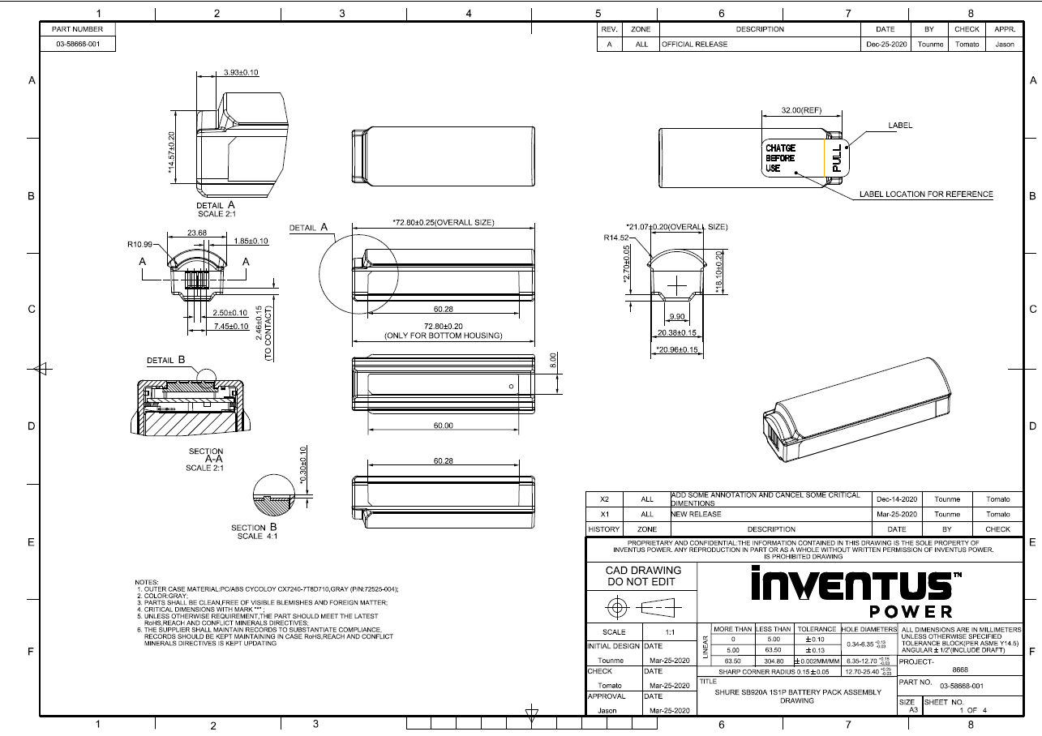

3.5 External dimension:
72.80±0.25 mm * 23.68±0.10 mm * 20.8 ±0.20 mm, Subjecting to 2D&3Ddrawing

3.6 Assembly requirement.

3.6.1 PCBA assembly require
Nickel sheet & welding spot can’t higher than bottom side as below image.
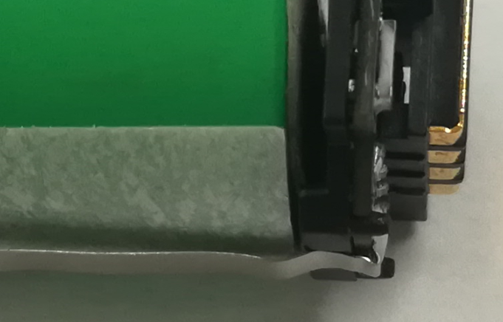
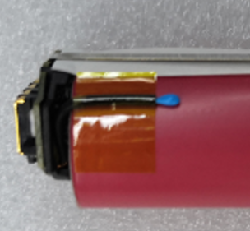
NG

3.6.2 NTC location requirement
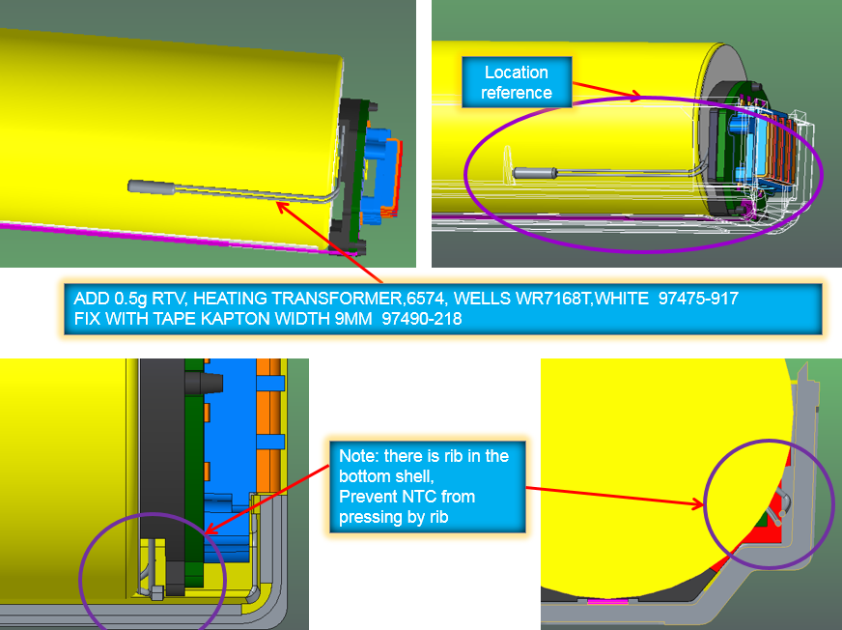

3.6.3 glue require
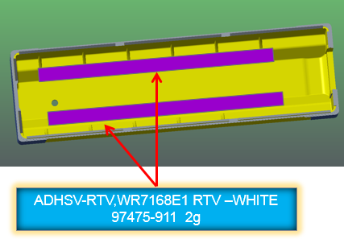
Add heating-transformer 0.15ML on NTC , Add yellow glue 0.5g , Heat shrinkable tube L=19±1mm 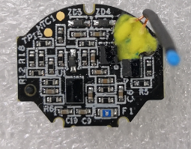
Heat shrinkable tube L=19±1mm
Heating transformer
0.15ML
L
Yellow glue 0.5g

4. ELECTRICAL SPECIFICATION
4.1 Over Voltage Protection (OVP) for Software: Cell voltage >=4.3V± 0.016V for 1s

4.2 Over Voltage Protection (OVP) recovery: Cell voltage <=4.2V±0.022V

4.3 Over voltage Protection (OVP) for Hardware: Cell voltage >=4.325V± 0.016V for 1S

4.4 Under Voltage Protection(UVP) for Software: Cell voltage<=2.85V±0.022V for 1s

4.5 Under Voltage Protection (UVP) recovery: Cell voltage>=3V±0.022V

4.6 Under Voltage Protection (UVP) for Hardware: Cell voltage<=2.438V±0.022V for 31.25ms

4.7 Over Current in Discharge (OCD): Discharge current>=4.35A±0.6A for 31.25ms

4.8 Over Current in Charge (OCC): Charge current>=1.8A+0.66/-0.54A for 7.81ms

4.9 Short Circuit in Discharge (SCD): Discharge current>=7.33A+1.15/-0.94A for 312.5us

4.10 Over Temperature in Discharge (OTD): Temperature>=60’C±5’C for 5s

4.11 Over Temperature in Discharge (OTD) recovery: Temperature<=55’C±5’C

4.12 Over Temperature in Charge (OTC): Temperature>=60’C±5’C for 5s

4.13 Over Temperature in Charge (OTC) recovery: Temperature<=55’C±5’C

4.14 Battery pack normal voltage: 3.6V

4.15 Battery pack capacity: 2500mA.H

4.16 Termination voltage in discharge: 3.0V

4.17 Charge Float Voltage: 4.2V±0.3V

4.18 Operating temperature in discharge: -18’C to 57’C

4.19 Operating temperature in charge: 0’C to 60’C (Note: Charge float voltage should be 4.05V at 45-60°C)

4.20 Fast charge current: 0.5C

4.21 Discharge power: 700 to 2200mW

4.22 Typical Impedance: 150mR±50mR

4.23 Electrostatic Discharge (ESD)
EN61000-4-2:1995 Level 4, +/-8kV Contact and +/-15kV Air Discharge

5. PRODUCT TEST PROCEDURE(All PARAMETER SHALL BE TEST AT ROOM AMBIENT TEMPERATURE TYPICALLY 25℃)
5.1 SOFTWARE VERSION
5.1.1 Software version:
5.1.2 Checksum code:
5.2 Calibrate Data list:
Item | Cal data | Resolution (LSB) | Spec | Test or not | remark
1 | Current 0mA | 1mA | ±5mA | 5.4.12
2 | Current -2000mA | 1mV | ±5mA | 5.4.12
3 | Cell Voltage 3600mV | 1mV | ±5mV | 5.4.12
4 | Room Temperature |  | ±2degC | 5.4.2
5

5.3 TEST DIARGRAM
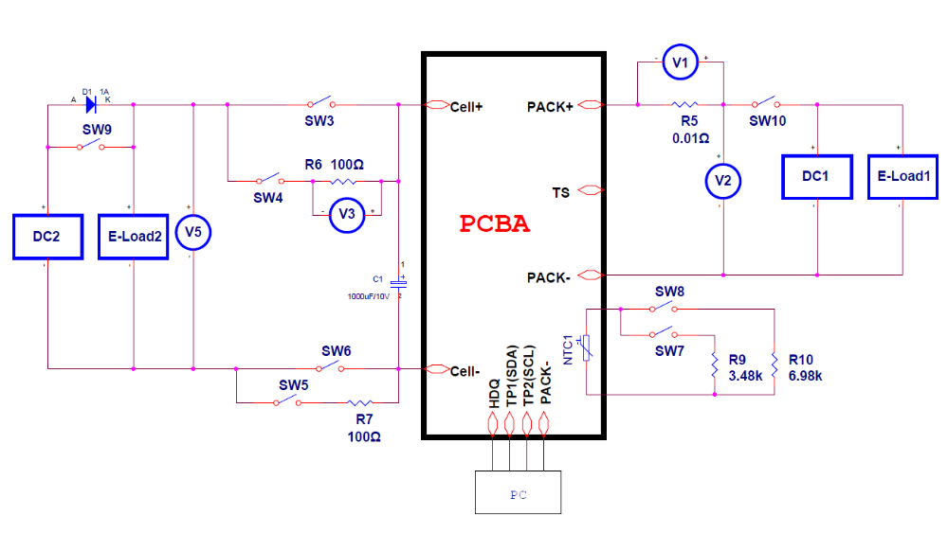
Figure-1 PCBA function test diagram
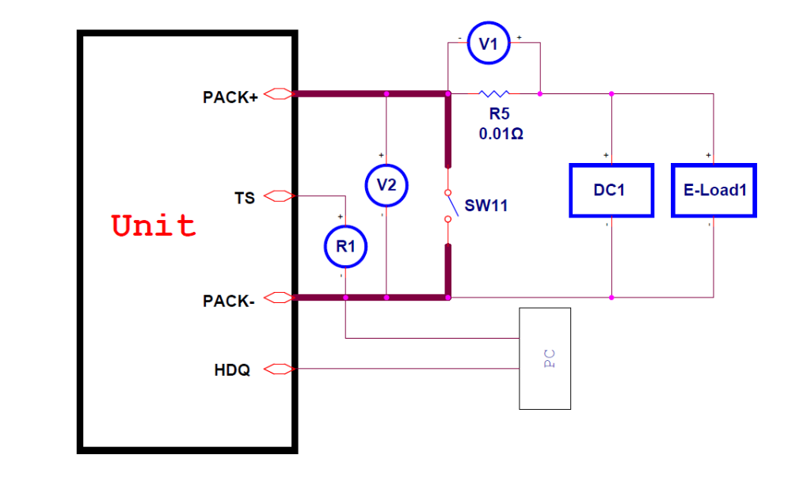
Figure-2 Final product function test diagram

5.4 PCBA FUNCTION test item and PROCEDURES

Item | Test description |  | Condition | SPEC | Remark
PCBA function testing
5.4.1 |  | Program | Refer to item 2 of “Product information Version List” |  | Test diagram refer to Figure-1
5.4.2 |  | Calibrate | Refer to item 4 of “Product information Version List” |  | Test diagram refer to Figure-1
5.4.3 |  | Over Voltage Protection (OVP) for software | - Set DC 1 CV=4.5V@1A  - Set DC2=5.5v@0.1A ;E-load2=CV:4.2V/3A  - Turn on SW3, SW6,SW10; Turn off SW4,SW5,SW7,SW8,SW9  - Turn on E-load2, DC2.  - Turn on DC1; V1=10mV±1mV.  - Increase E-load2 voltage to 4.316V.  (Record the V5 value for OVP value)  - After 2s, test V1<=0.1mV.  - Turn down E-load2 voltage to 4.178V.  (Record the V5 value for OVP recovery value)  - After 2s V1=10mV±1mV  - Turn off DC1, DC2, E-load2. | - OVP:  4.3V±0.016V  b. OVP recovery:  4.2V±0.022V | Test diagram refer to Figure-1 (Only test max. limit and min. limit to judge PASS/Fail after PP)
5.4.4 |  | Over Current in Charge (OCC) | - Set DC 1 CV=4.2V@2.3A  - Set DC2=5.5v@0.1A ;E-load2=CV:3.6V/3A  - Turn on SW3, SW6,SW10; Turn off SW4,SW5,SW7,SW8,SW9  - Turn on E-load2, DC2.  - Turn on DC1; V1=23mV±1mV.  - Increase DC1 current to 3.56A  After 1s V1<0.1mV(Record the OCC value)  - Turn off DC1  - Set DC1 CV:4.2V@1A  - Turn on DC1, V1=10mV±1mV(Recovery: Pass or fail)  - Turn off DC1, DC2, E-load2. | a. OCC:  1.8A+0.66/-0.54A  b. OCC recovery:  Pass or fail (V1=10mV±1mV is Pass) | Test diagram refer to Figure-1 (Only test max. limit and min. limit to judge PASS/Fail after PP)
5.4.5 |  | Low voltage charge function | - Set DC 1 CV=4.2V@0.3A  - Set DC2=5.5v@0.1A ;E-load2=CV:1.3V/3A  - Turn on SW3, SW6,SW10; Turn off SW4,SW5,SW7,SW8,SW9  - Turn on E-load2, DC2.  - Turn on DC1; V1<0.1mV  - Increase E-load2 voltage to be 1.7V  (Record the V5 voltage as low voltage charge voltage)  - After 1s V1=3mV±1mV  - Turn off DC1, DC2, E-load2. | Low voltage charge voltage:  Vcell>1.55V±0.15V | Test diagram refer to Figure-1 (Only test max. limit and min. limit to judge PASS/Fail after PP)
5.4.6 |  | Under Voltage Protection (UVP) | - Set DC1 CV=4.2V@0.1A  - Set DC2=5.5v@0.1A ;E-load2=CV:3.1V/3A  - Turn on SW3, SW6,SW10; Turn off SW4,SW5,SW7,SW8,SW9  - Turn on DC2, E-load2  - Turn on DC1, then turn off DC1.(Activate)  - V2=3.1V±0.1V  - Turn down E-load2 voltage to 2.828V  (Record the V5 value for UVP)  - After 2s V2<0.1V  - Set DC1 4.2V@0.1A  - Turn on DC1  - Increase E-load2 voltage to 3.022V  (Record the V5 value for UVP recovery)  - Then turn off DC1. V2=3.022V±0.1V  - Turn off DC1, DC2, E-load2. | - UVP:  2.85V±0.022V  b. UVP recovery:  3V±0.022V | Test diagram refer to Figure-1 (Only test max. limit and min. limit to judge PASS/Fail after PP)
5.4.7 |  | Over Current in Discharge (OCD) | - Set DC1 CV=4.2V@0.1A, E-load1= CC2.7A  - Set DC2=3.8V@10A  - Turn on SW3, SW6,SW9,SW10; Turn off SW4,SW5,SW7,SW8  - Turn on DC2.  - Turn on DC1, after 1s turn off DC1.(Activate)  - V2=3.8V±0.1V  - Turn on E-load1  - Increase E-load1 current to be 4.95A  (Record the current V1 for OCD)  - After 5s, V2<0.1V  - Turn off SW10  - After 1s, V2=3.8V±0.1(Recovery: Pass or Fail)  - Turn off DC1, DC2, E-load2. | a. OCD  4.35A±0.6A  b. Recovery:  Pass or Fail (V2=3.8V±0.1 is pass) | Test diagram refer to Figure-1 (Only test max. limit and min. limit to judge PASS/Fail after PP)
5.4.8 |  | NTC2 test | Use multimeter to test the NTC2 （Between TS and PACK-) resistance value. The temperature of NTC and environment should less than 5’C | +/-5’C | Test diagram refer to Figure-1
5.4.10 |  | Leak current | - Set DC 1 CV=4.2V@0.1A  - Set DC2=5.5v@0.1A ;E-load2=CV:3.6V/3A  - Turn on SW3, SW6,SW10; Turn off SW4,SW5,SW7,SW8,SW9  - Turn on E-load2,DC2  - Turn on DC1, then turn off DC1(active)  - Wait for 10 seconds, and record V3 voltage ,5mV<=V3 <= 15mV(50uA-150uA)  - Gradually decrease E-load2 voltage down to 2.65V  Wait for 10 seconds  - Record V3 voltage, V3 Less than 1mV (1uA).  - Turn off DC1, DC2,E-load2. | Sleep model Dissipation current :  50 to 150uA;  Shut-down dissipation current :  ≤1uA | Test diagram refer to Figure-1
5.4.11 |  | I2C communication test | - Connect I2C communication to PC  - Set DC1 CV=4.2V@0.1A E-load1: CC 2A  - Set DC2=3.6v@4A  - Turn on SW3, SW6,SW9,SW10; Turn off SW4,SW5,SW7,SW8  - Turn on DC2  - Turn on DC1, after 1s turn off DC1.(Activate)  - Record offset voltage between FG and multimeter:  △VCell=V5-V_{I2C_cell}<±5mV  △Current_0A= V1*100-I_{I2C_current}<±5mA  h. Turn on E-load1  △Current_2A= V1*100-I_{I2C_current}<±5mA  i. Turn off DC1, DC2, E-load2. | Offset voltage between FG and PCBA:  1, △VCell < ±5mV;  2, △Current_0A <±5mA  3. △Current_2A<±5mA  4. △Temperature_25’C<±3’C | Test diagram refer to Figure-1
5.4.12 |  | I2C convert to HDQ test | Proto A no requirement |  | Test diagram refer to Figure-1

5.5 Final product FUNCTION test item and PROCEDURES
Item | Test description |  | Condition |  |  | SPEC |  | Remark
Final product function testing
5.5.1 |  | Send IT enable command | Refer to item 6 of “Product information Version List”
5.5.2 |  | Over current in Discharge | - Set E-load1 to be CC:4.95A(Or use a 0.5 ohm resistance)  - Turn on E-load1  - After 5s, V2<0.1V  - Turn off E-load1  - After 1s, V2=3.6V±0.2(Recovery: Pass or fail) | OCD  4.35A±0.6A  b. Recovery:  Pass or Fail (V2=3.6V±0.2 is pass) |  |  | Test diagram refer to Figure-2 (Only test max. limit and min. limit to judge PASS/Fail after PP)
5.5.3 |  | Burn in test | - Set DC1 4.2V@1.25A  - Turn on DC1  - Charging the battery pack 10 minutes  - Turn off DC1, and rest battery pack 5minutes  - Use 5ohm resistor load for 15 about minutes  - The SOC control to 45% to 55% |  |  |  | Test diagram refer to Figure-2  At MP, test or not decided by QX
5.5.4 |  | AC impedance | - Set impedance meter in AC model, Frequence =1kHz  - Test internal impedance at B+ and B- port. | 80mR~150mR
5.5.5 |  | DC impedance | - Test the Open Circuit Voltage(OCV) V2_1  - Set E-load: CC1A  - Turn on E-load  - Wait for about 3s, record the output voltage V2_2  - DC impedance= (V2_2-V2_1)/1 | 150mR±50mR
5.5.6 |  | NTC2 test | Use multimeter to test the NTC2 （Between TS and PACK-) resistance value. The temperature of NTC and environment should less than 5’C | +/-5’C |  |  | Test diagram refer to Figure-2
5.5.7 |  | Temperature detect error | - Connect HDQ communication  - Read the temperature by HDQ as T1  - Read the AMT by thermometer as T2  - △T=T1-T2<=±3’C | △T=T1-T2<=±3’C |  |  | Test diagram refer to Figure-2
5.5.8 |  | △OCV after five days | - Rest battery 2 hour  b. Test OCV1  c. Rest battery pack 5 day  d. Test OCV2  e. Calculate :OCV1-OCV2 and date2-date1  △OCV=10mV Max; △date=5 day Min | △OCV=V1-V2  = 10mV Max |  |  | It must be test at PP. At MP, test or not decided by QX
5.5.9 |  | Lifetime data write and Write information | Reset the following Pack parameters to values match released GG file and write information  Write information refer to section 10: manufacture information
  Name | init | Unit
  Lifetime Max Temp | 25 | .C
  Lifetime Min Temp | 25 | .C
  Lifetime Max Pack Voltage | 3600 | mV
  Lifetime Min Pack Voltage | 3600 | mV
  Lifetime Max Chg Current | 0 | mA
  Lifetime Max Dsg Current | 0 | mA
5.5.10 |  | Lifetime data check and  Verify information | Read and verify the life time data and information
  Name | Verify | Unit
  Lifetime Max Temp | 0<T<35 | .C
  Lifetime Min Temp | 0<T<35 | .C
  Lifetime Max Pack Voltage | 3000<V<4200 | mV
  Lifetime Min Pack Voltage | 3000<V<4200 | mV
  Lifetime Max Chg Current | 0<Imax<2000 | mA
  Lifetime Max Dsg Current | -2000<Imax<0 | mA
5.5.13 |  | Seal | Send the seal command, Refer to item 6 of “Product information Version List”
5.5.14 |  | Check seal | Check seal status, Refer to item 6 of “Product information Version List”
5.5.15 |  | Shipping capacity | - Read the SOC and FCC from HDQ,  - test the no load output voltage with multimeter when ship out based on cell OCV table to set the spec(SOC: 20%±10%) |  | OCV: 3.55V±0.05V
5.5.16a |  | Shutdown Progress | Send the shutdown command, Refer to item 6 of “Product information Version List” | Pass or fail
5.5.16b |  | Shutdown verification | Check shutdown status, Refer to item 6 of “Product information Version List” | Pass or fail

6. Mechanical
Test | Test Variables / Required Inputs | Numerical Specification | Acceptance Criteria
Drop Test | Units stored at 0°C for 3 hours and drop 10x on hardwood at 40" | 0°C product: 10 Drops, 40", Hardwood. 100% State of Charge | No cracks or breakage acceptable.
Vibration Random (Min Integrity Test) | 20-500Hz random vibration profile of 0.040 g2/Hz (modified version of MIL-STD810G 514.6 Annex E). 1/2 hour for each of 3 axis. | 20-500HZ 1/2 each axis  100% State of charge | No cracks or breakage acceptable.
Individual Packaged Drop | Units are dropped onto various corners, edges and faces of the packaging as described in the procedure, method 2. Drop height is 48". | 7 drops 48" on concrete, 4 packages. Standard shipping state of charge (40%). 1 charge discharge cycle completed | If the packaging tested is product display boxes, packaging should meet the above standards for package type (although package damage can be greater due to the additional height), as well as the IATA requirements. Otherwise, for master cartons, and bulk shipment cartons the requirements are only the IATA requirements. Units must also be within specifications.  The IATA requirements are as follows (applies to all cartons in this category):  • Damage to cells or batteries contained therein;  • Shifting of the contents so as to allow battery to battery (or cell to cell) contact;  • Release of contents

Test Name | Description
Appearance Direct View Molded/Die Cast | This is a primary surface or part and is in direct view of the user in normal use. Visually check that part matches the current blueprint. Inspect the part in indoor cool white diffused fluorescent lighting (80-120 foot candles). Hold part approximately 12 inches (30 cm.) from eyes (no magnification). Rotate part and decide if appearance is acceptable within 4-6 seconds. The following is not acceptable:  • Missing, misaligned or misoriented labels.  • Parts not clean and free of foreign matter including mold release, oil or any form of contamination.  • Cracked, broken, warped or distorted parts.  • Flash from ultrasonic welding, sink, drag marks, short shots, flow lines, blush, burrs, marred surfaces, scratches or other surface imperfections.  • Other obvious damage  • Incorrect/missing datecode  Note: It is unacceptable to have more than 1 defect 0.020 inch in length, width or diameter in any single field of view.

Quality Assurance Requirement

- Package And Label
8.1 Unit label (refer to the latest E-drawing in EQMS system: PN 90947-723 )
8.2 Warning label (refer to the latest E-drawing in EQMS system: PN 90947-724 )
8.3 SN label (refer to the latest E-drawing in EQMS system: PN 90947-725 )
8.4 Packaging drawing (refer to the latest E-drawing in EQMS system: PN 03-58668-001 )

- Engineering Change

- Manufacture Information

